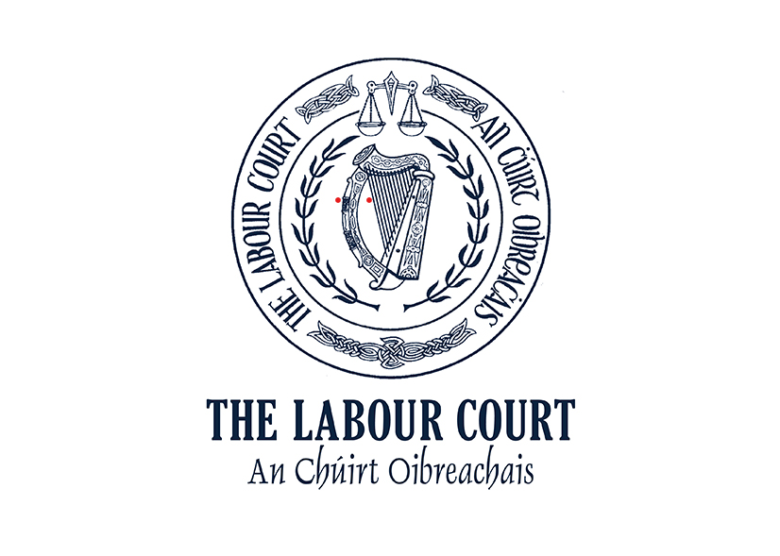
Sick Leave Act 2022
APPLICATION FOR EXEMPTION FROM THE PROVISIONS OF THE ACT

Employer Details: -
Name of employer:
Sector/Industry:
Postal address:
Email address:
Contact name:
Telephone number:

Employer’s Representative details (if any):-
Name of representative
Postal address:
Email address:
Contact name:
Telephone number:

Summary of grounds on which application for an exemption is made:-

Signature of Employer: __________________________________ Date: __________

Parties are advised that decisions of the Court are published on its website www.labourcourt.ie

Note: please see overleaf for details of documents which must accompany the application

Documents to be Furnished with Application Form
The Sick Leave Act 2022 provides (Sick Leave Act 2022, Section 10 (irishstatutebook.ie)) that the Labour Court may exempt an employer from the obligation to pay an employee or employees statutory sick leave payment otherwise payable under the Act. The Act specifies that before granting an exemption the Labour Court must be satisfied(a) that the majority of their employees and/or their representatives/ trade union consent to the application being made and to abide by any decision on the application that the Court may make and (b) the employer’s business is experiencing severe financial difficulties.

The following documents must accompany the application for exemption: -
- An agreement including a collective agreement in which the majority of the employees in respect of whom the exemption is sought, or their representative/trade union consent to (a) the employer making the application for the exemption and (b) to abide by any decision on the application that the Labour Court may make OR where the employer only has one employee an agreement with the employee and or the employee’s representative/trade union in which the employee consents to the application and agrees to abide by any decision on the application that the Labour Court may make.
- A list of the names and occupations of the employees in respect of whom the application for exemption is made.
- A financial report setting out the financial difficulties experienced by the employer’s business at the time of the application and in what way such difficulties are severe.

Completed applications, together with the documents specified at 1, 2 and 3 above should be returned to: -

The Labour Court
Lansdowne House, Lansdowne Road
Dublin 4, D04A3A8
Ph: 01 613 6666 or 0818 613 6666 Email: info@labourcourt.ie

The Labour Court will allocate a date for the hearing of the application for exemption as soon as possible after receipt of a valid application.

